Threat Network Support Systems & Graph Architecture

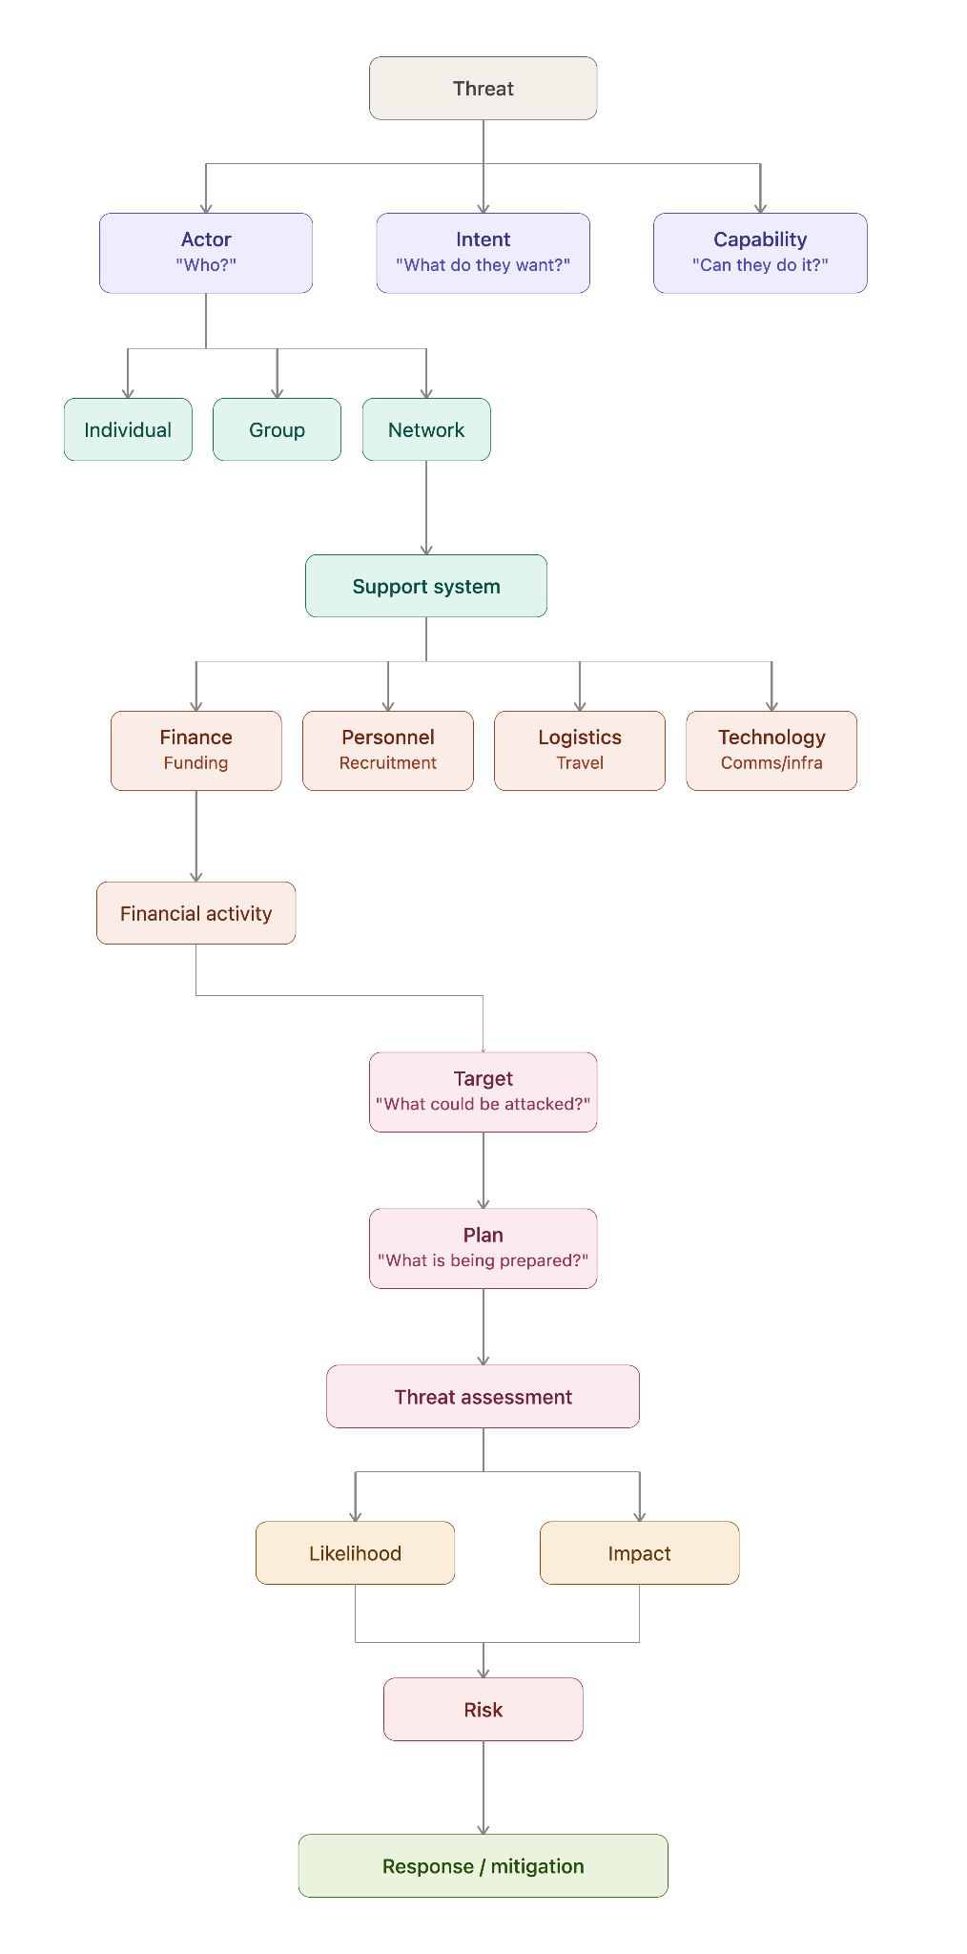

1. Executive Summary & Taxonomy
Threat actors and illicit organizations do not operate in isolation. The ecosystem is structured across 17 granular operational support components:
- Financial Support: Asset transfers, money intermediaries, digital payments, front companies, and informal financial corridors.
- Human Support: Core leadership, specialists, facilitators, couriers, advisers, and functional intermediaries.
- Recruitment Support: Infiltration channels, online communities, ideological influencers, and training pipelines.
- Logistical Support: Safe housing, transport corridors, staging storage, and procurement intermediaries.
- Communication Support: Encrypted messaging, radio networks, telecommunications metadata, and dead drops.
- Technology Support: Command-and-control infrastructure, server hosting, encryption, and custom software pipelines.
- Material Support: Tactical gear, electronics, vehicles, and medical supply caches.
- Training & Knowledge Support: Tactical instruction, operational security (OPSEC) education, and technical tradecraft sharing.
- Political & Institutional Support: State or local political shielding, institutional corruption, and advocacy fronts.
- Social Support: Kinship, tribal alliances, community trust enclaves, and diaspora logistics.
- Ideological Support: Propaganda networks, radicalization platforms, and public-facing narratives.
- Information Support: Target reconnaissance, open-source intelligence (OSINT) gathering, and human intelligence sources.
- Legal & Administrative Support: Paperwork manipulation, shell entity registration, and legal defense coordination.
- Infrastructure Support: Warehouses, cloud computing accounts, landing strips, and private facilities.
- External Support: Cross-border state sponsors, diaspora financing, and foreign broker networks.
- Concealment & Protection Support: Obfuscated beneficial ownership, burner aliases, and compartmentalized organizational cells.
- Operational Execution Support: The immediate convergence of all upstream assets into an active tactical operation.

2. Seven-Class Graph Taxonomy
To avoid dimensional bloat inside an intelligence database, the 17 operational areas converge into seven parent meta-classes:
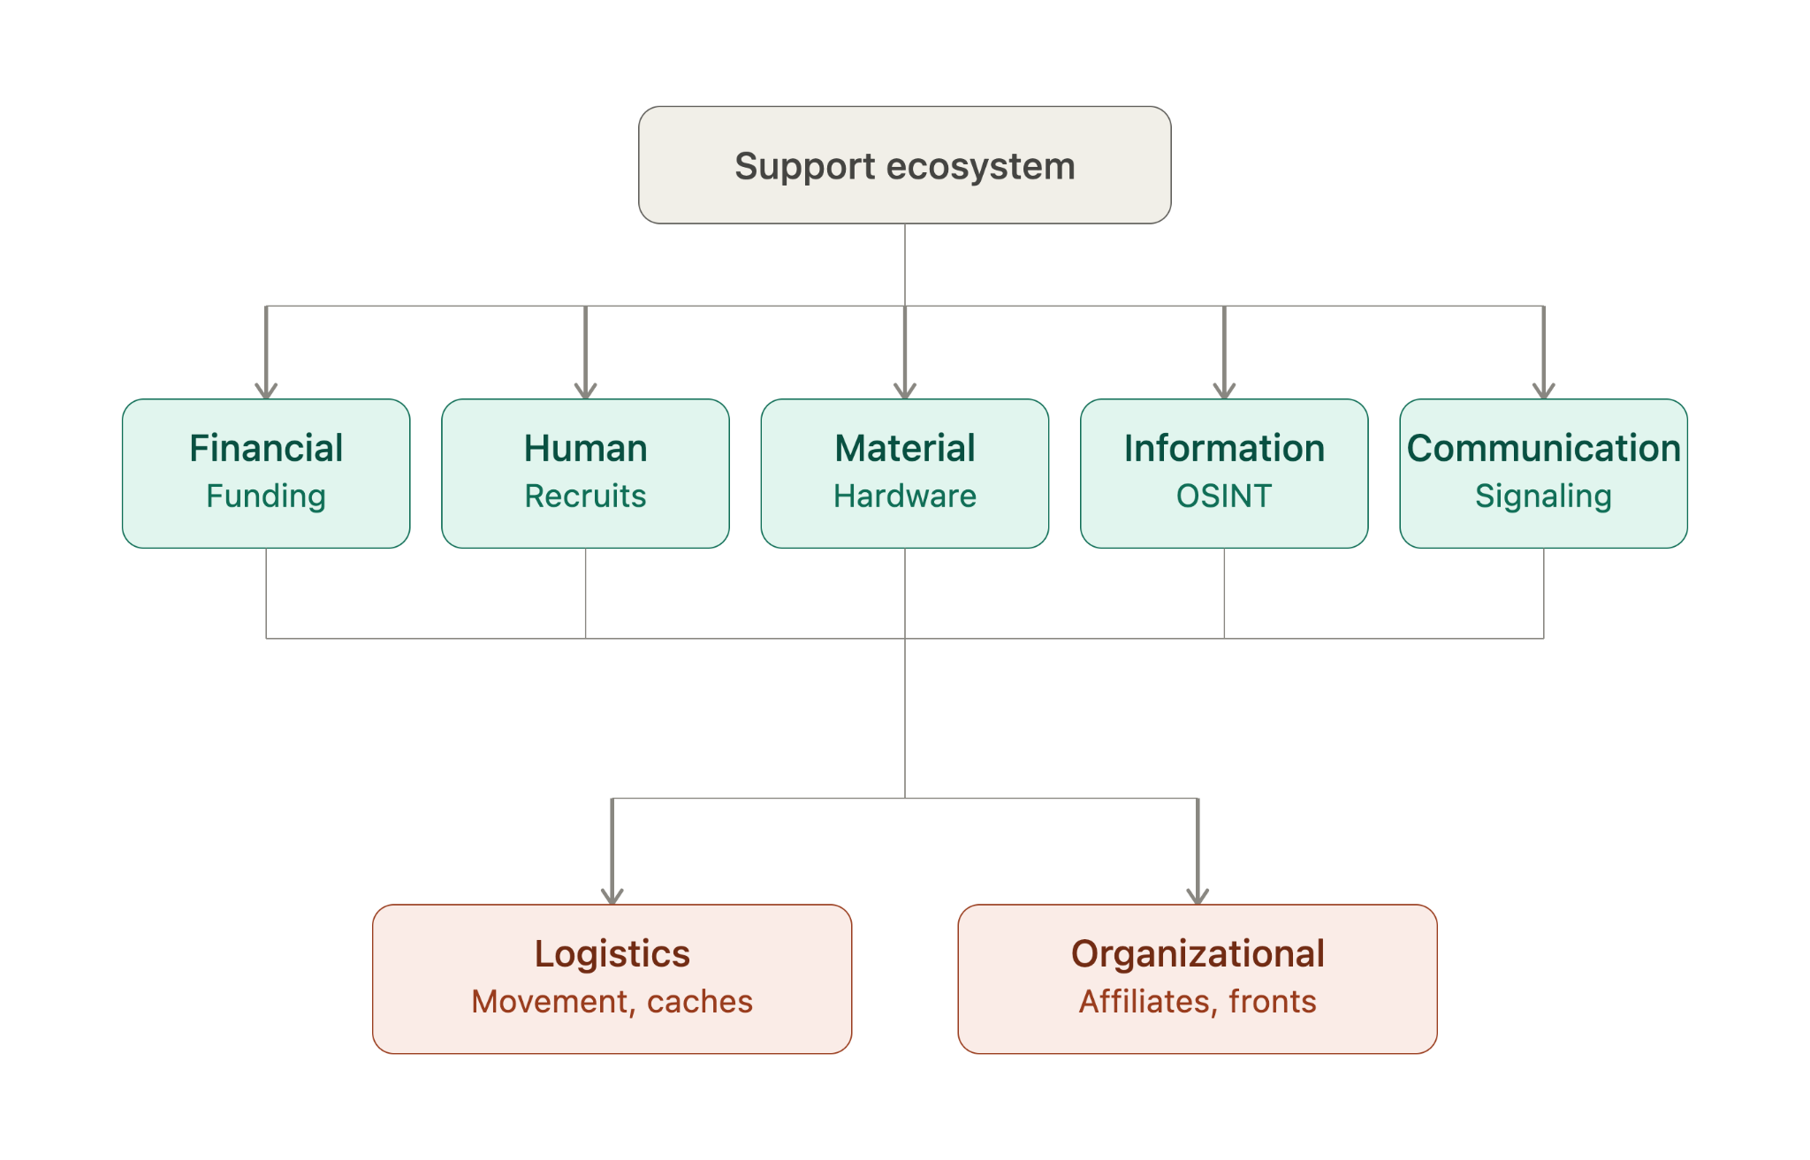

3. Threat Traceability Ranking & Intelligence Blindspots
Investigative friction is dictated by visibility limits, data compartmentalization, and regulatory coverage.
Difficulty Tier | Support Domain | Core Operational Blindspot
Very High | Informal Financial Networks (Hawala) | Value transfers occur without ledger footprints inside regulated banking environments.
Very High | Human & Social Trust Enclaves | Familial and offline personal trust leave zero institutional traces.
Very High | Concealed Ultimate Beneficial Ownership | Layered offshore trusts and nominee directors legally mask actual network principals.
High | Ephemeral & Encrypted Communications | End-to-end encryption eliminates content analysis; requires complex traffic analysis.
High | Cross-Border Operational Routing | Jurisdictional borders create delays in data acquisition across sovereign entities.
High | Pseudonymous Online Operations | Single operators mask actions behind synthetic or rotated digital profiles.
Medium-High | Distributed Logistics & Supply Routing | Individual transport legs mimic standard commercial retail and logistics traffic.
Medium | Regulated Corporate Networks | Discoverable through commercial registers, though often slowed by multi-state filings.
Low-Medium | Formal Core Banking Transactions | Financial intelligence units (FIUs) easily track SWIFT, SEPA, and clearing accounts.
Low | Registered Titled Assets | Real estate and registered transport assets maintain public registry records.

